TASK 2 REPORT
Task 2: Data Cleaning & Preprocessing
Objective:
To clean the dataset by handling missing values and preparing it for analysis.
Code:
# ==============================
# STEP 1: IMPORT LIBRARIES
# ==============================

import pandas as pd
import numpy as np
import matplotlib.pyplot as plt
import seaborn as sns

# ==============================
# STEP 2: LOAD DATA
# ==============================

df = pd.read_csv("superstore_final_dataset.csv", encoding='latin1')

print("First 5 rows:")
display(df.head())

# ==============================
# STEP 3: CLEAN COLUMN NAMES
# ==============================

df.columns = df.columns.str.strip()

# ==============================
# STEP 4: DATA CLEANING
# ==============================

df = df.dropna()
df = df.drop_duplicates()

# Convert date column
df["Order_Date"] = pd.to_datetime(df["Order_Date"], dayfirst=True)

# ==============================
# STEP 5: KPIs
# ==============================

total_revenue = df["Sales"].sum()

avg_order_value = df["Sales"].mean()

print("\nKPIs:")
print("Total Revenue:", total_revenue)
print("Average Order Value:", avg_order_value)

# ==============================
# STEP 6: REGION-WISE SALES
# ==============================

region_sales = df.groupby("Region")["Sales"].sum()

plt.figure()
region_sales.plot(kind="bar")
plt.title("Sales by Region")
plt.ylabel("Sales")
plt.show()

# ==============================
# STEP 7: CATEGORY ANALYSIS
# ==============================

category_sales = df.groupby("Category")["Sales"].sum()

plt.figure()
category_sales.plot(kind="bar")
plt.title("Sales by Category")
plt.show()

# ==============================
# STEP 8: TIME ANALYSIS
# ==============================

df["Month"] = df["Order_Date"].dt.month

monthly_sales = df.groupby("Month")["Sales"].sum()

plt.figure()
monthly_sales.plot()
plt.title("Monthly Sales Trend")
plt.show()

# ==============================
# STEP 9: TOP PRODUCTS
# ==============================

top_products = df.groupby("Product_Name")["Sales"].sum().sort_values(ascending=False).head(10)

plt.figure()
top_products.plot(kind="bar")
plt.title("Top 10 Products")
plt.xticks(rotation=45)
plt.show()

# ==============================
# STEP 10: WORST PRODUCTS
# ==============================

worst_products = df.groupby("Product_Name")["Sales"].sum().sort_values().head(10)

plt.figure()
worst_products.plot(kind="bar")
plt.title("Worst 10 Products")
plt.xticks(rotation=45)
plt.show()

# ==============================
# STEP 11: FINAL OUTPUT
# ==============================

print("\nFinal Data:")
display(df.head())
Output:
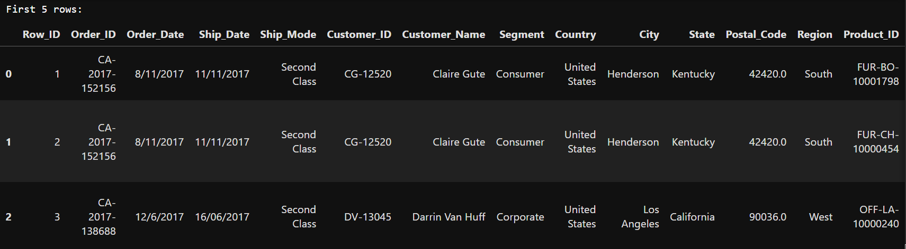
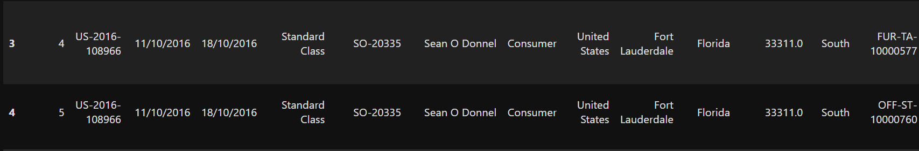
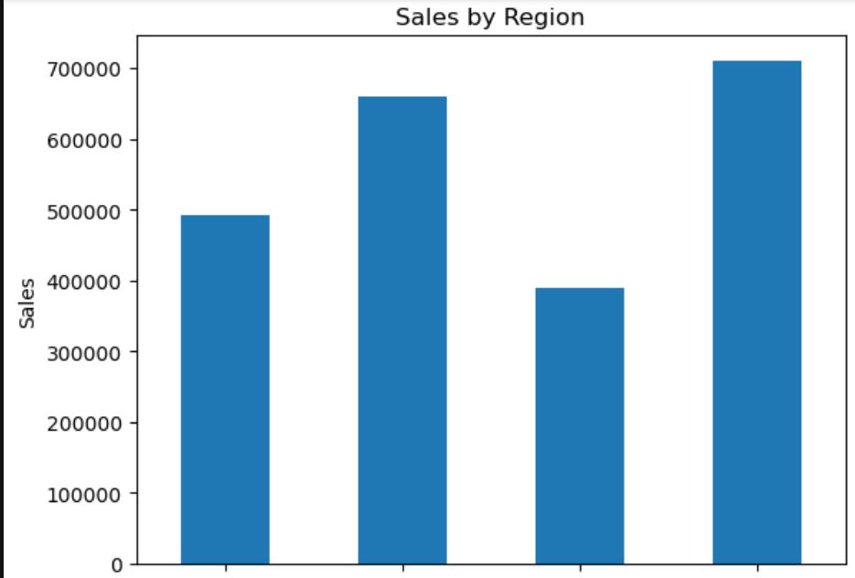
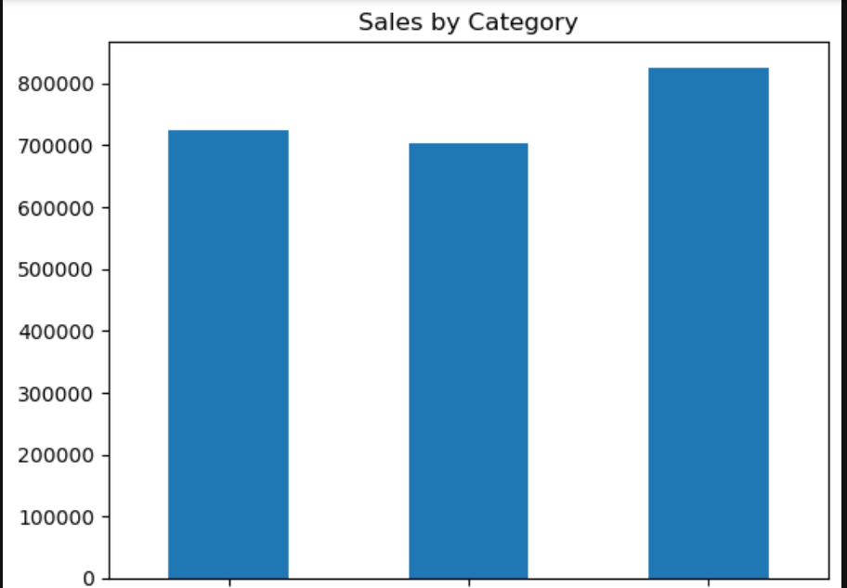
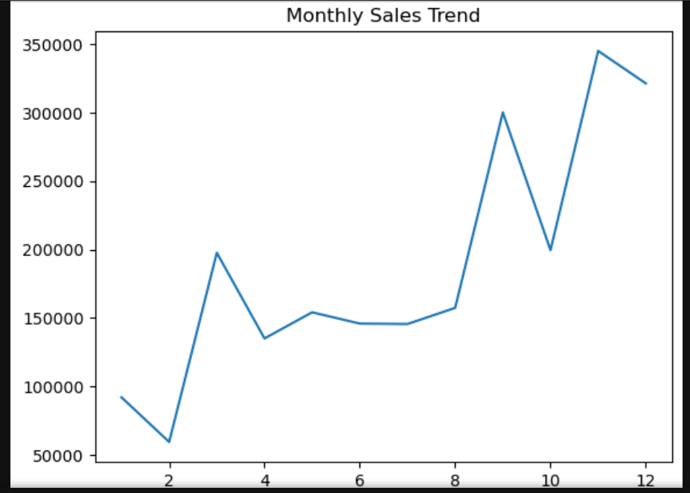
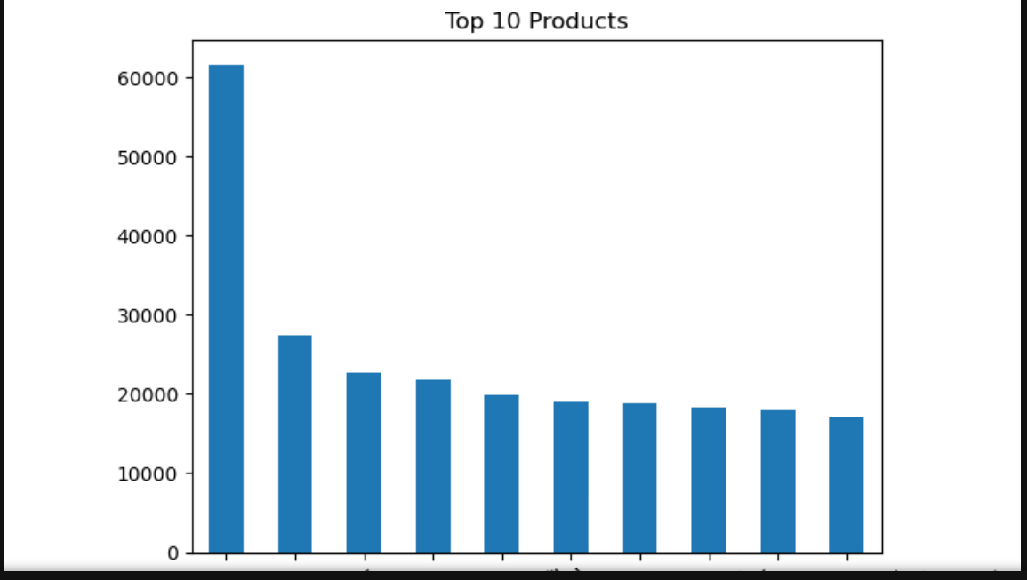
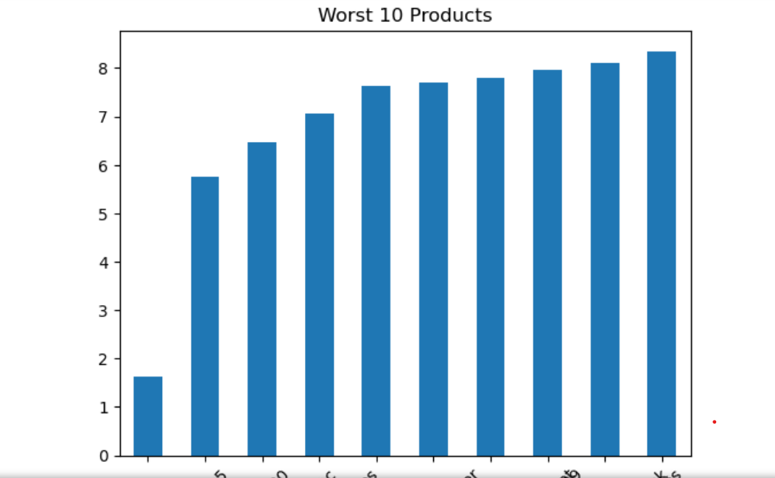
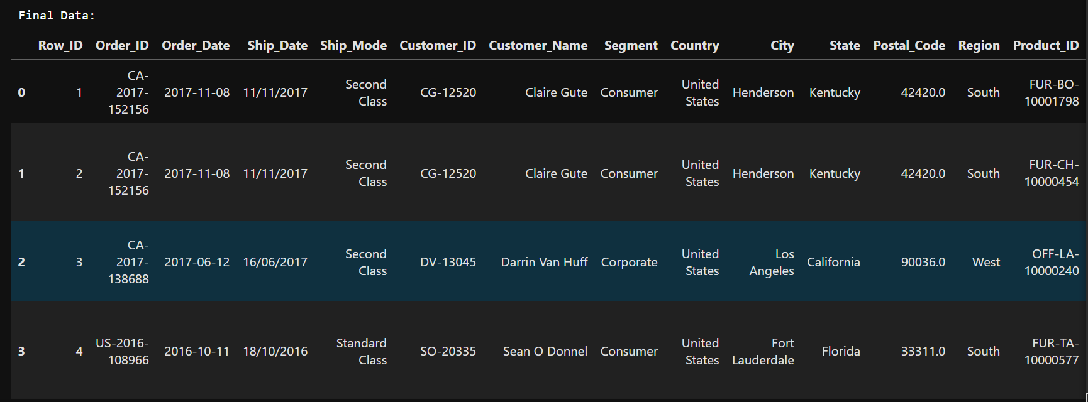

Summary:
In this task, data cleaning was performed to improve data quality. Missing values were handled, unnecessary columns were removed, and the dataset was made consistent. This step is crucial as clean data ensures accurate analysis and reliable results.

